

DEPARTMENT OF COMPUTER SCIENCE – UBIT

“Assembly language”

CSSE – 403

Chaudhary Usama Ishtiaq

Section ‘A’ (EVENING)

EB23210106023

Submitted to: SIR FAROOQ

ASSIGNMENT-03

**LAB TASK # 03**

**Q:** Display your name and father’s name

**INPUT:**

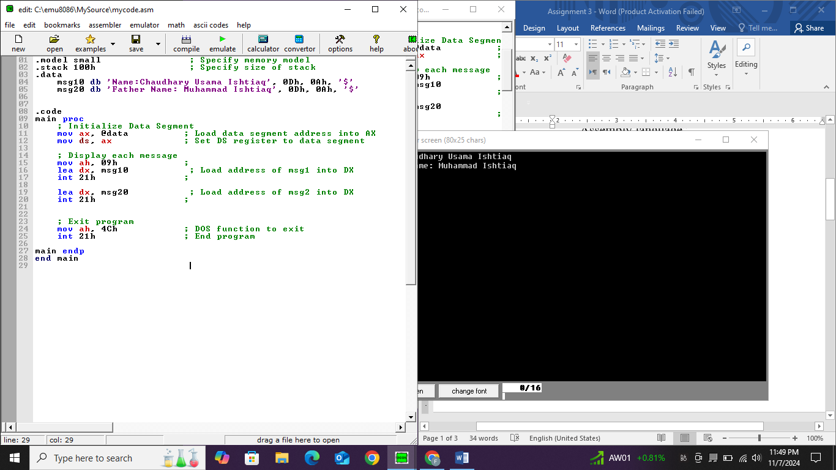

**OUTPUT:**

